**Lab 12: Graphics**

**OBJECTIVE:** Graphics in Assembly.

* Video interrupt
* Interrupt functions
* Video modes
* Key board interrupt

**Video Programming:**

* Basic background
* Controlling the color
* Int 10h video functions

**Int 10h:**

* Video Functions Interrupt
* Preserves only BX, CX,DX and segment registers.
* Other registers preserve onto stack before calling 10h.
* Ah = video Function Number.
* Al = Function Mode
* Mov ah,0 ;set video mode
* Mov al,3 ;choose mode 3
* Int 10h

**Screen Mode Numbers:**

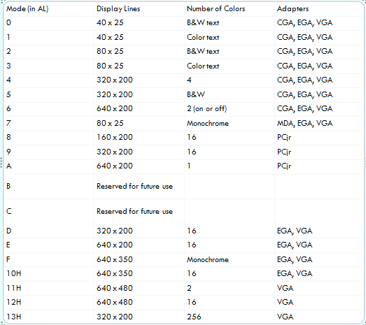

**Getting Pixels AH=0CH:**

* Display a pixel…
  + - MOV AH, 0Ch
    - MOV AL, Color Number
    - MOV CX, X-axis ; CX = 10
    - MOV DX, Y-axis ; DX = 20
    - INT 10H
  + Example
    - MOV Al,00 ;Black Color
    - MOV Al,01 ;Blue Color
* MOV Al,03 ;Green Color

**Access to pixel:**

* Get/spot a pixel on screen by specify the row and column number.
* CX having Column Number
* DX having Row Number
* AL Color Number
* MOV AH, 0CH having function number for put a pixel on screen
  + Example
    - MOV CX, 10
    - MOV dx, 10
    - MOV al, 01 ;Blue
    - MOV ah, 0CH
    - INT 10H

**Clear Screen (CLS):**

* Put them in in procedur and call whenever you want to clear the screen.
* Example
  + - myfunction proc
    - MOV AL,03
    - MOV AH,0
    - INT 10H
    - ret
    - myfunction endp

Now call this procedure by “CALL myfunction”

**Cursor Position (Goto XY) AH=02:**

* Set cursor position using function number AH=02H.
* BH having page number (0,1,2,…)
* DX having Row and Column numbers (DH=ROW, DL=Column).
* Example
  + - MOV AH,02H
    - MOV DH, 10 ;Row Number
    - MOV DL, 20 ;Column Number
    - INT 10H

**Change Background Color AH=06:**

* Change background color using 06H funtion number of INT 10H
* MOV AH,06H
* AL having Scrol line
* BH having background and foreground color
* CX having (CH= upper row number, CL left coloumn number)
* DX having (DH= upper row number, DL left coloumn number)
  + Example
    - MOV AH, 06h
    - MOV AL, 0
    - MOV CX, 0
    - MOV DH, 80
    - MOV DL, 80
    - MOV BH, 14h
    - INT 10h

**Function Numbers With Parameters:**

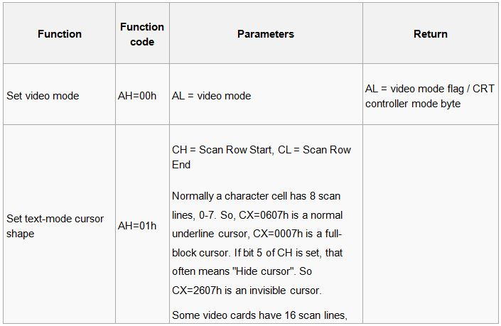

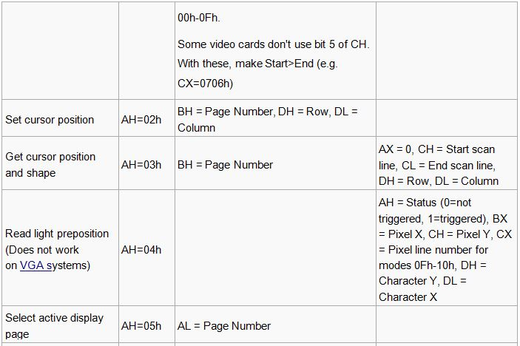

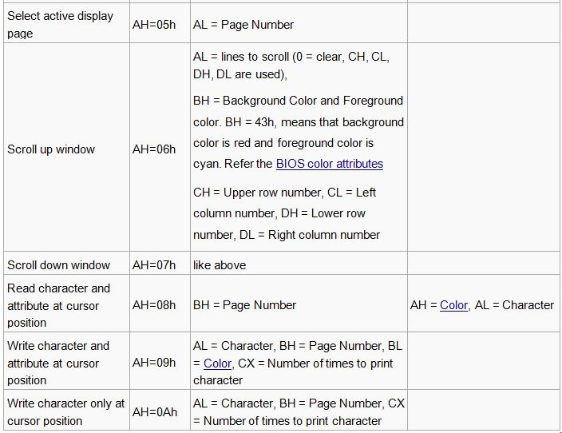

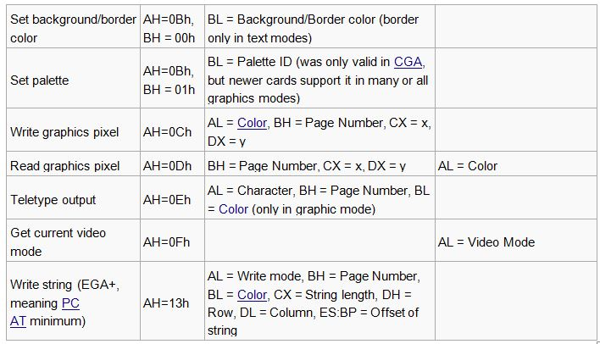

**Activities:**

* Draw a border of any ASCII character in the center of the screen and write your name in this border using (MOV AH,02H),(MOV AH,09H) of BIOS interrupt (INT 10H).
* Draw a Square full of pixels by using (MOV AH,0CH)
* Draw a Rectangular by using ASCII character . (MOV AH,02H),(MOV AH,09H) of BIOS interrupt (INT 10H).